Employee Master Data Management using SAP RAP (RESTful ABAP Programming Model)

WORKFLOW OF THIS PROJECT
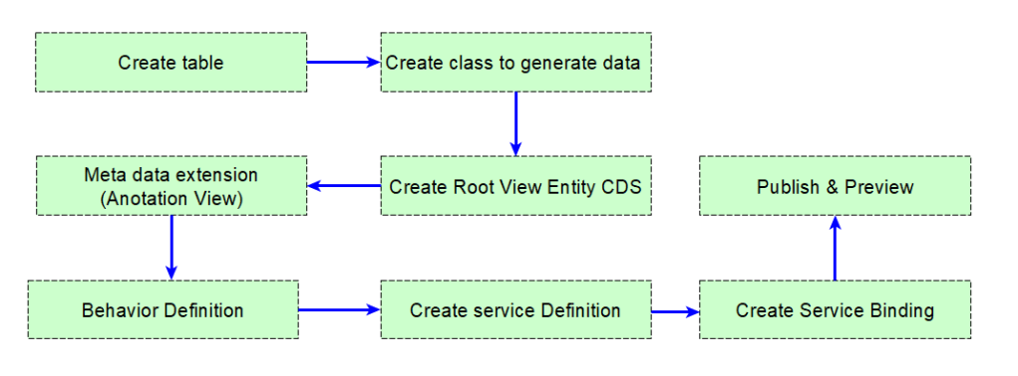
STEP-1 CREATE A DATABASE TABLE INSIDE ADT :
@EndUserText.label : 'EMPLOYEE TABLE BY ELISAYA'
@AbapCatalog.enhancement.category : #NOT_EXTENSIBLE
@AbapCatalog.tableCategory : #TRANSPARENT
@AbapCatalog.deliveryClass : #A
@AbapCatalog.dataMaintenance : #ALLOWED
define table zeli_emp1 {
key client : abap.clnt not null;
key employee_id : abap.char(3) not null;
employee_name : abap.char(15);
department : abap.char(20);
manager : abap.char(20);
@Semantics.amount.currencyCode : 'zeli_emp1.currency'
salary : abap.curr(7,2);
currency : abap.cuky;

}
STEP-2 HOW TO INSERT DATA INSIDE THE DATABSE TABLE
CLASS zeli_class_data_insert DEFINITION
PUBLIC
FINAL
CREATE PUBLIC .

PUBLIC SECTION.
INTERFACES if_oo_adt_classrun."THIS INTERRFACE WILL HAVE ONE METHOD.
PROTECTED SECTION.
PRIVATE SECTION.
ENDCLASS.

CLASS zeli_class_data_insert IMPLEMENTATION.
METHOD if_oo_adt_classrun~main.
DATA: lt_data TYPE TABLE OF zeli_emp1.
lt_data = VALUE #(
( employee_id = 'E01' employee_name = 'ELISAYA NAYAK' department = 'SAP ABAP' manager = 'VIRAT' salary = 6000 currency = 'USD' )
( employee_id = 'E02' employee_name = 'JERRY NAYAK' department = 'SAP ABAP' manager = 'VIRAT' salary = 5000 currency = 'USD' )
( employee_id = 'E03' employee_name = 'GLORY NAYAK' department = 'SAP ABAP' manager = 'VIRAT' salary = 7000 currency = 'USD' )
( employee_id = 'E04' employee_name = 'SUSHILA NAYAK' department = 'SAP ABAP' manager = 'VIRAT' salary = 8000 currency = 'USD' )
( employee_id = 'E05' employee_name = 'RASANTA NAYAK' department = 'SAP ABAP' manager = 'VIRAT' salary = 8000 currency = 'USD' )

).

INSERT zeli_emp1 FROM TABLE @lt_data. " PERFORMING INSERT IS SUCCESFULLY".
SELECT * FROM zeli_emp1 INTO TABLE @data(it_result)."TESTING THE DATA IS SUCCESFULLY INSERTED IN TABLE OR NOT ".
out->write( EXPORTING data = it_result ).
ENDMETHOD.
ENDCLASS.

STEP- 3 CDS VIEW CREATE WITH TEMPLATE ROOT VIEW ENITITY
@AccessControl.authorizationCheck: #NOT_REQUIRED
@EndUserText.label: 'FIRST CDS VIEW TO DISPLAY EMPLOYEE DATA'
@Metadata.allowExtensions: true
@Metadata.ignorePropagatedAnnotations: false
define root view entity ZELI_CDS_VIEW02 as select from zeli_emp1
{
key employee_id as Employee_ID,
employee_name as Employee_Name,
department as Department,
manager as Manager,
salary as Salary,
currency as Currency
}

STEP-4 CREATE METADATA EXTENSION FOR CDS VIEW TO CREATE RAP APPLICATION
Create meta data extension – Anotation view with @UI
Metadata extension is created to annotate the CDS Entity and fields. We add description, screen position details etc., through these annotations – UI for Fiori application.

@Metadata.layer: #CORE
@UI: {
headerInfo: {
typeName: 'Employee Detail',
typeNamePlural: 'List Employee - Table Header',
title: { value: 'Employee_ID' }
}
}
annotate view ZELI_CDS_VIEW02
with
{
/* ================= OBJECT PAGE ================= */

@UI.facet: [
{
id: 'Detail',
purpose: #STANDARD,
type: #IDENTIFICATION_REFERENCE,
label: 'Employee Detail',
position: 10
}
]

/* ================= LIST REPORT + OBJECT PAGE ================= */

@UI: {
lineItem: [{ position: 10 }],
identification: [{ label: 'Employee ID', position: 10 }]
}
Employee_ID;

@UI: {
lineItem: [{ position: 20 }],
identification: [{ label: 'Employee Name', position: 20 }]
}
Employee_Name;

@UI: {
lineItem: [{ position: 30 }],
identification: [{ label: 'Department', position: 30 }]
}
Department;

@UI: {
lineItem: [{ position: 40 }],
identification: [{ label: 'Manager', position: 40 }]
}
Manager;

@UI: {
lineItem: [{ position: 50 }],
identification: [{ label: 'Salary', position: 50 }]
}
Salary;

@UI: {
lineItem: [{ position: 60 }],
identification: [{ label: 'Currency', position: 60 }]
}
Currency;
}

STEP-5 CREATE BEHAVIOR DEFINATION
Behavior Definition is created to specify operation details that are possible for the Entity. This refers to CRUD operations. By default READ / QUERY operations are enabled.
managed implementation in class zbp_eli_cds_view02 unique;
strict ( 2 );

define behavior for ZELI_CDS_VIEW02
persistent table zeli_emp1
lock master
authorization master ( none )
{
create;
update;
delete;

field ( readonly :update) Employee_ID;
}

STEP-6 Create service definition
Service definition defines which CDS entities are exposed as part of the service.

@EndUserText.label: 'SERVICE DEFINATION FOR RAP EMPLOYEE'
define service ZELI_CDS_ENITIY {
expose ZELI_CDS_VIEW02;
}

STEP-7 Create service binding
Service binding is created to Publish the service. Here, we chose the protocol like OData V2.

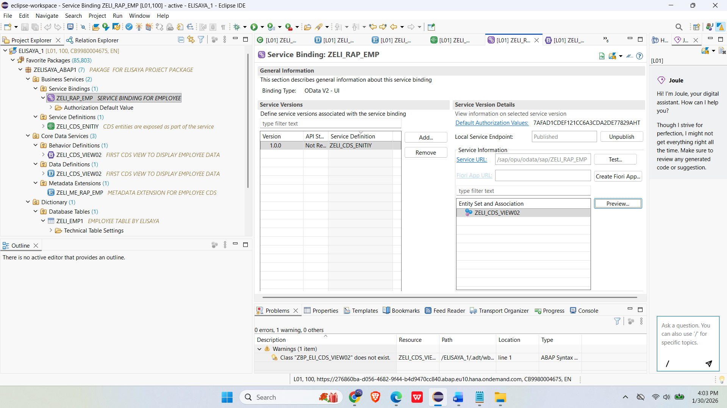

RESULT
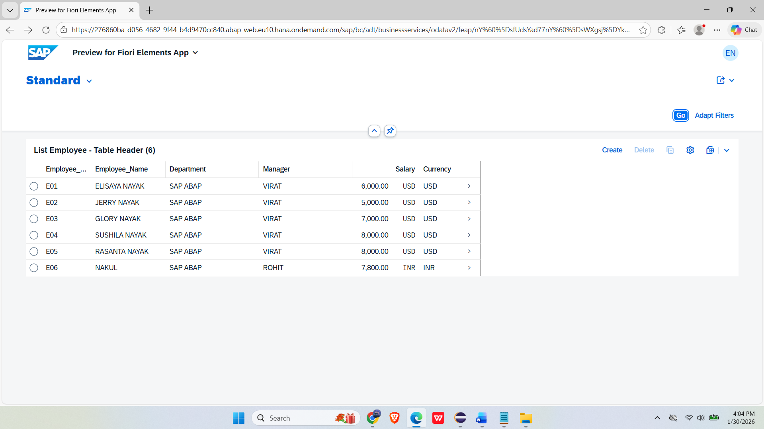

CREATE ENTRIES (Create)
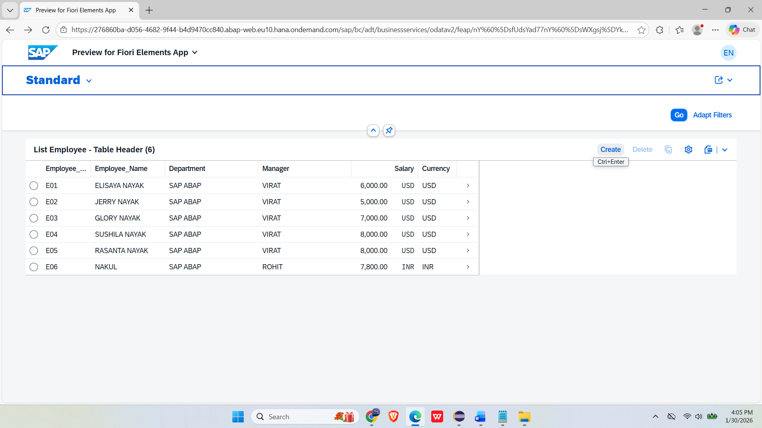

CLICK SAVE OPTION FOR SAVING ENTRIES IN DATABASE TABLE

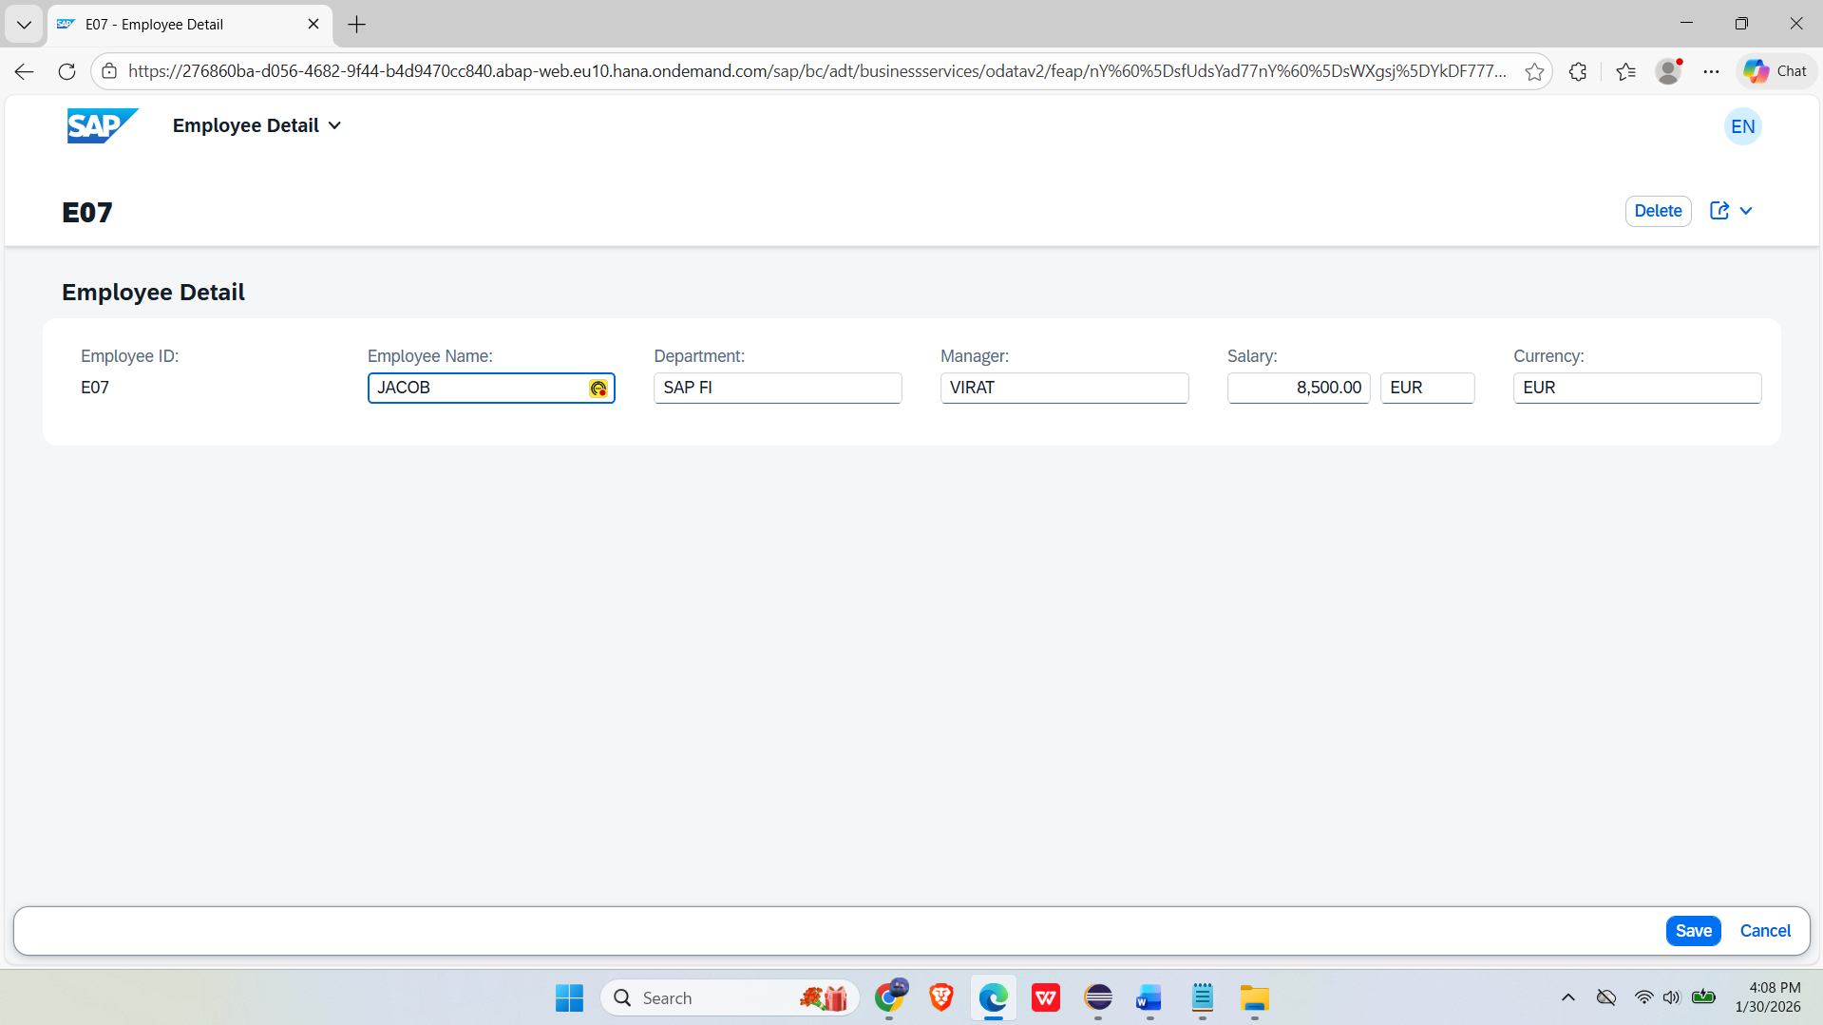
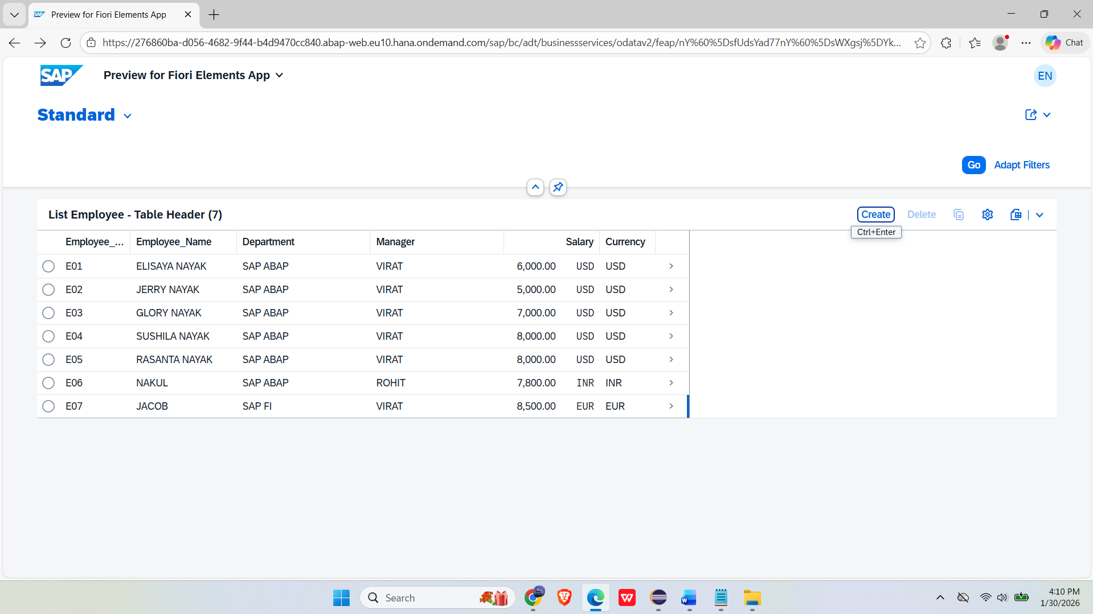

DELETE DATA (CLICK ON DELETE AFTER SELECT)

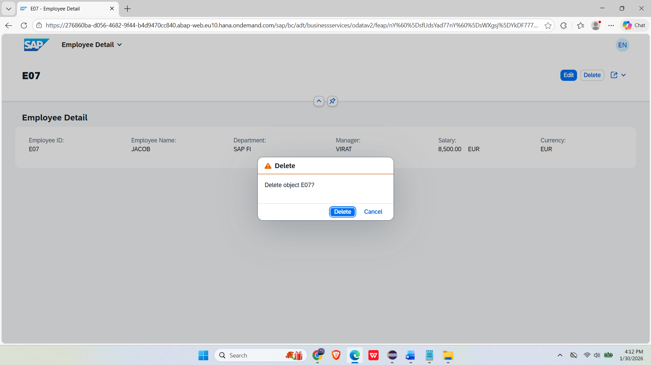
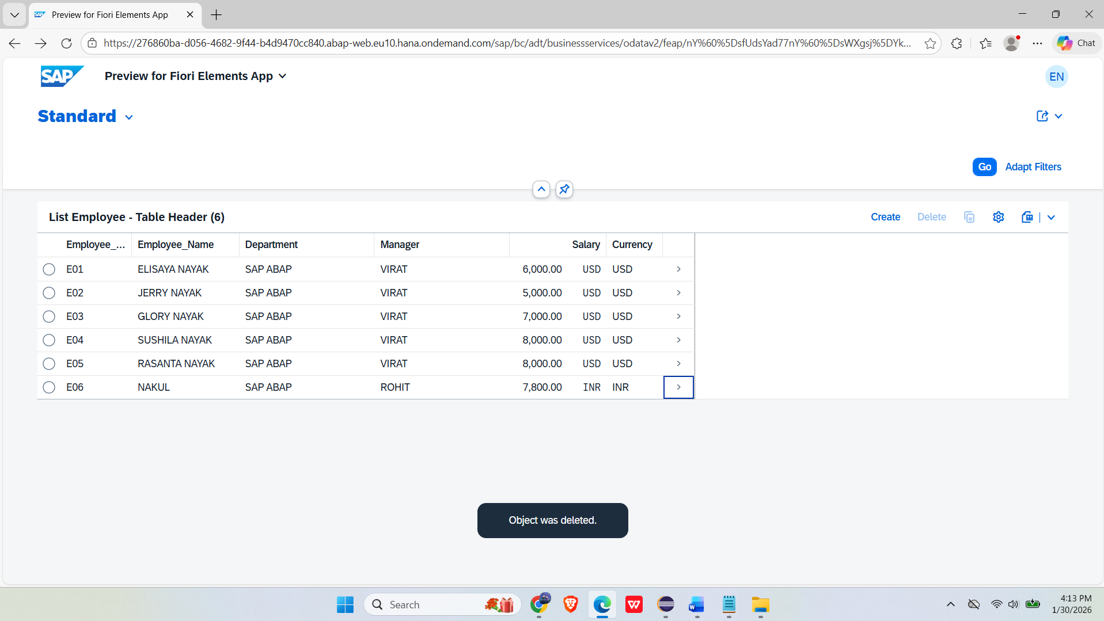
AFTER OPERATION ON WEB IT WILL ALSO CHANGE IN REAL DATABASE TABLE
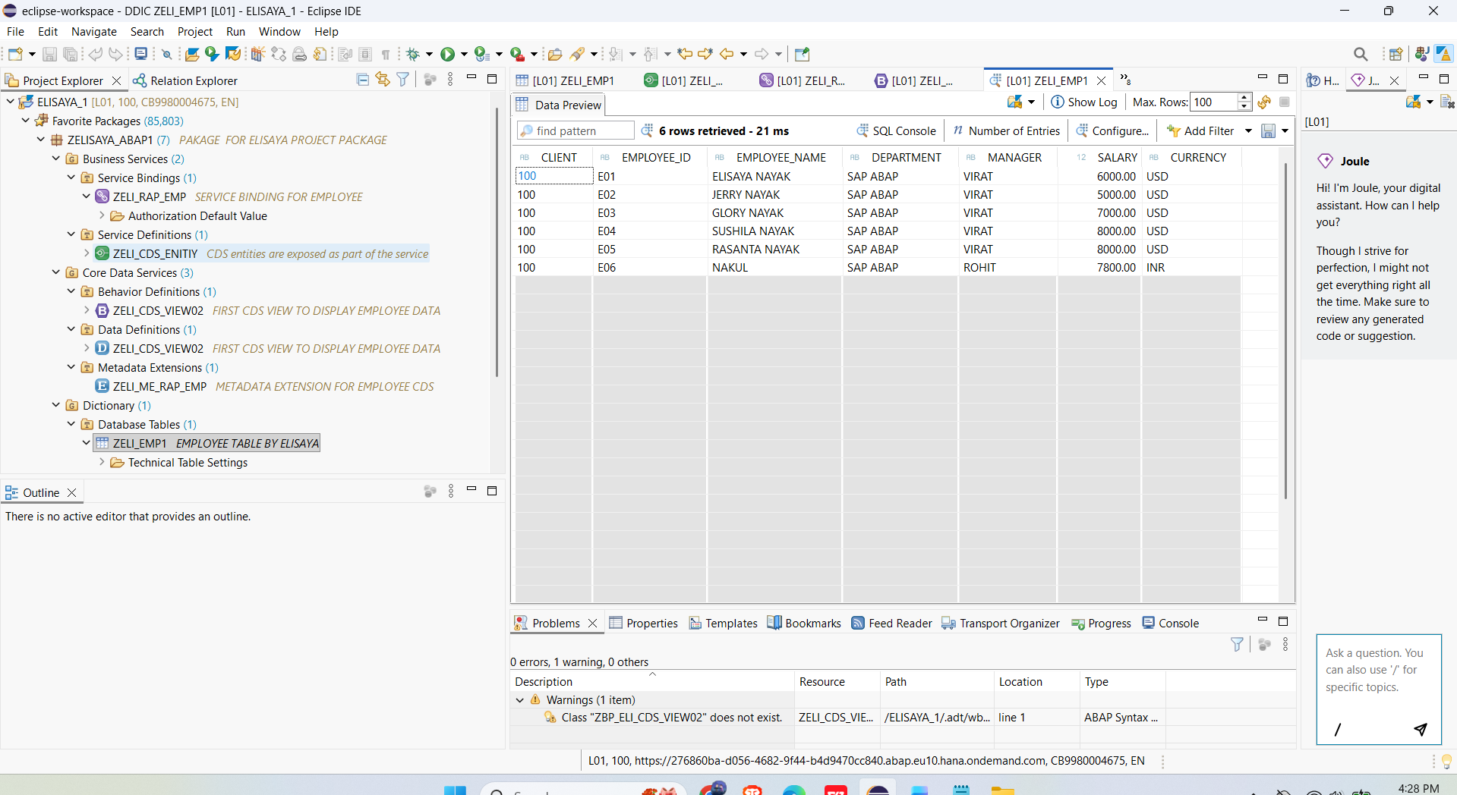

AFTER OPERATION ON YOU CAN SEND THROUGH EMAIL

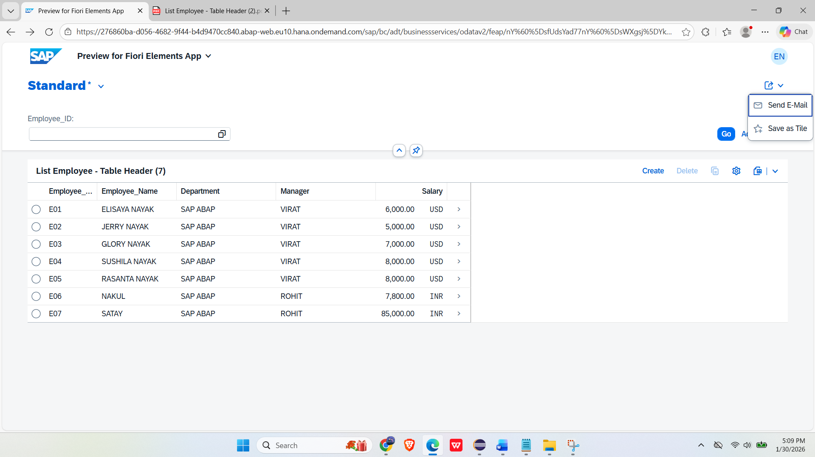
EXPORT TO Excel
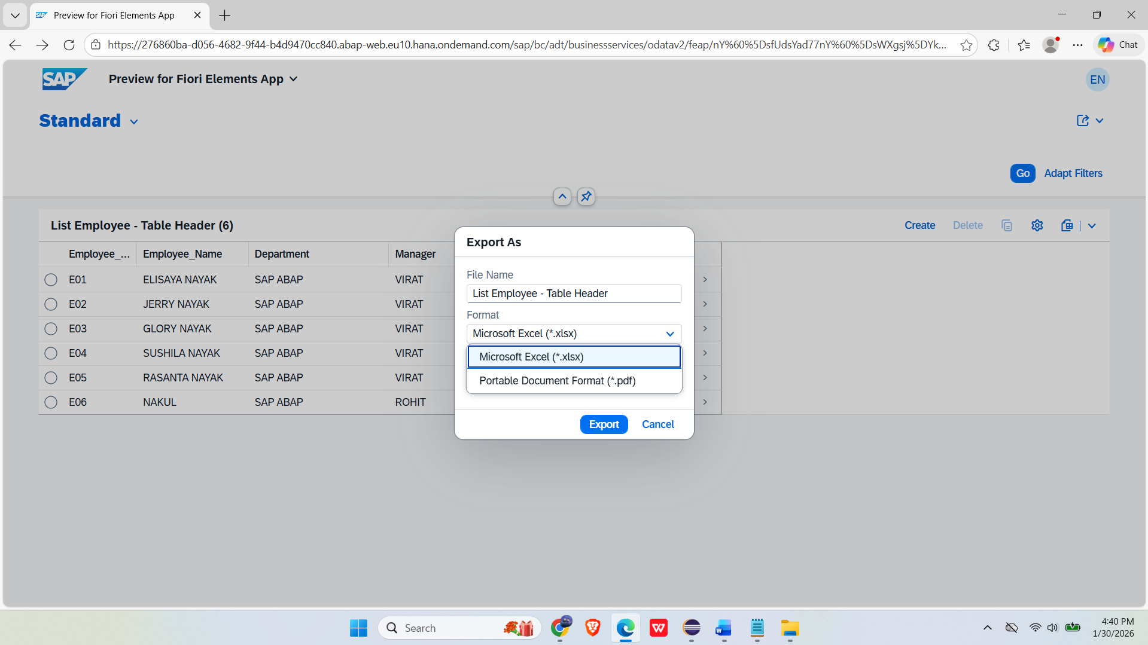
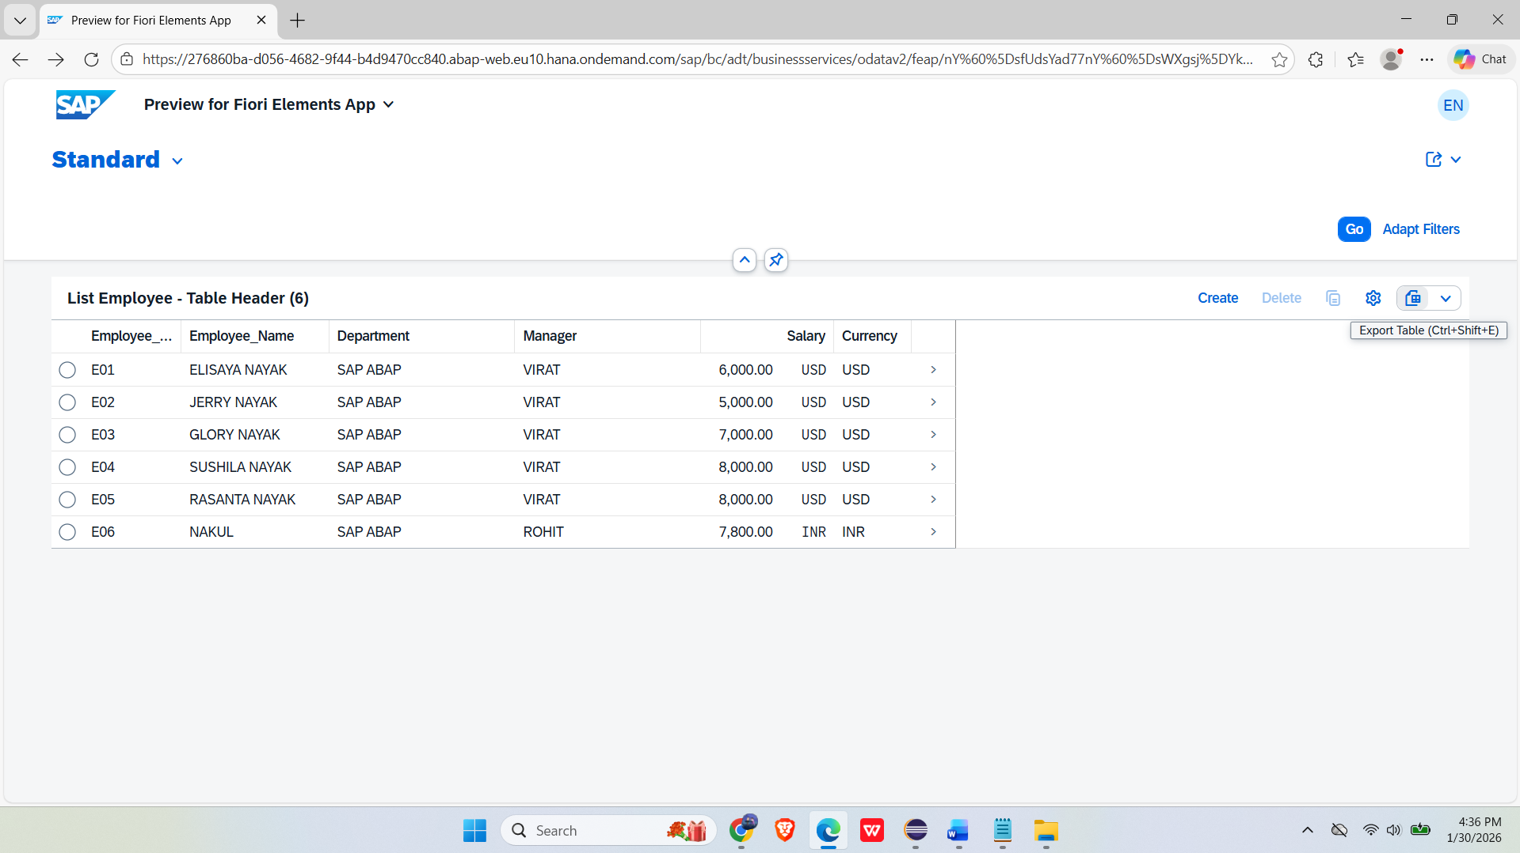
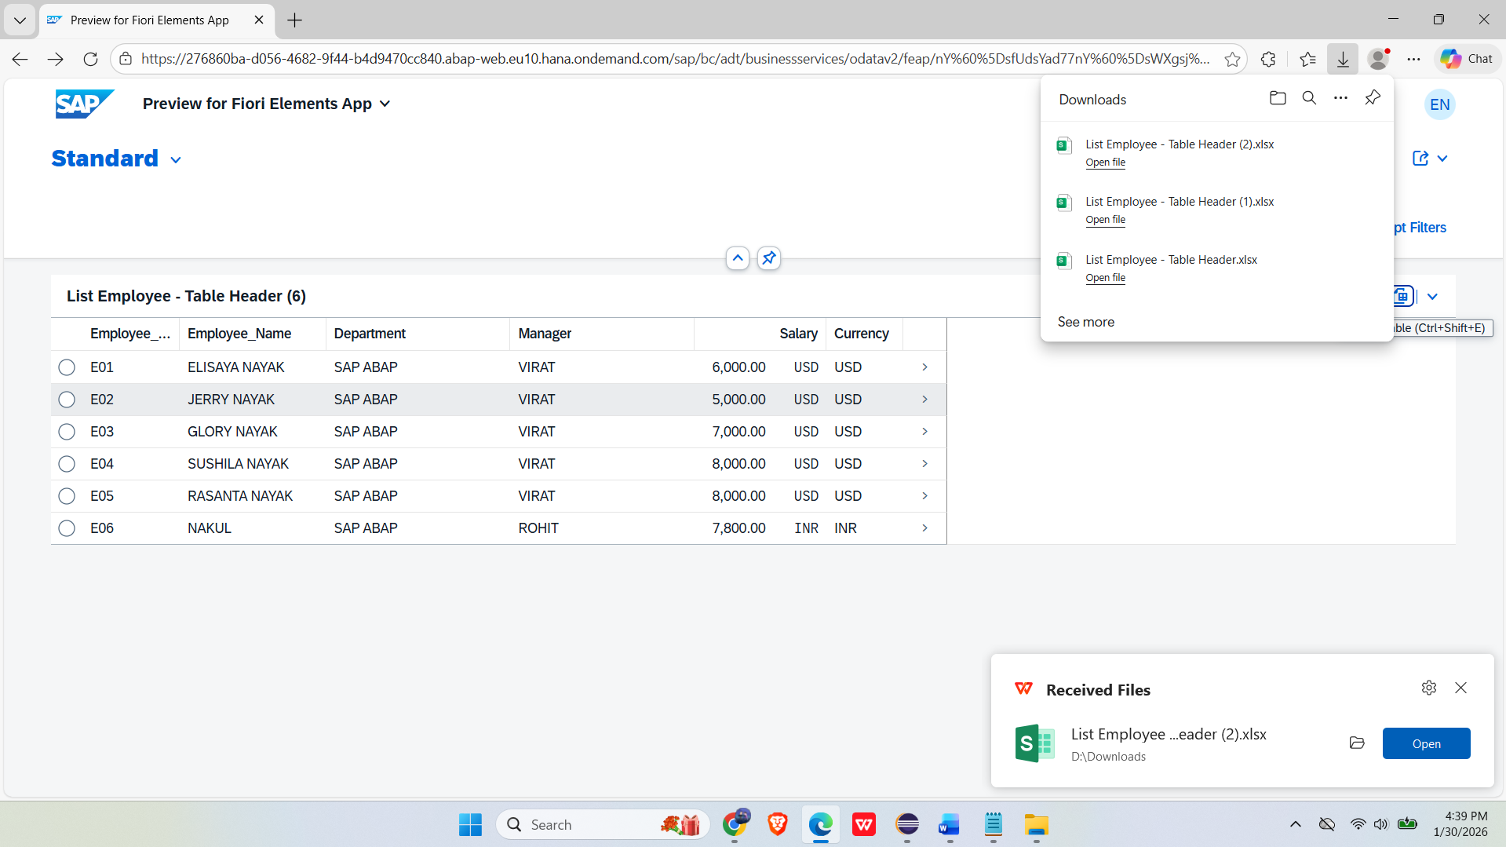
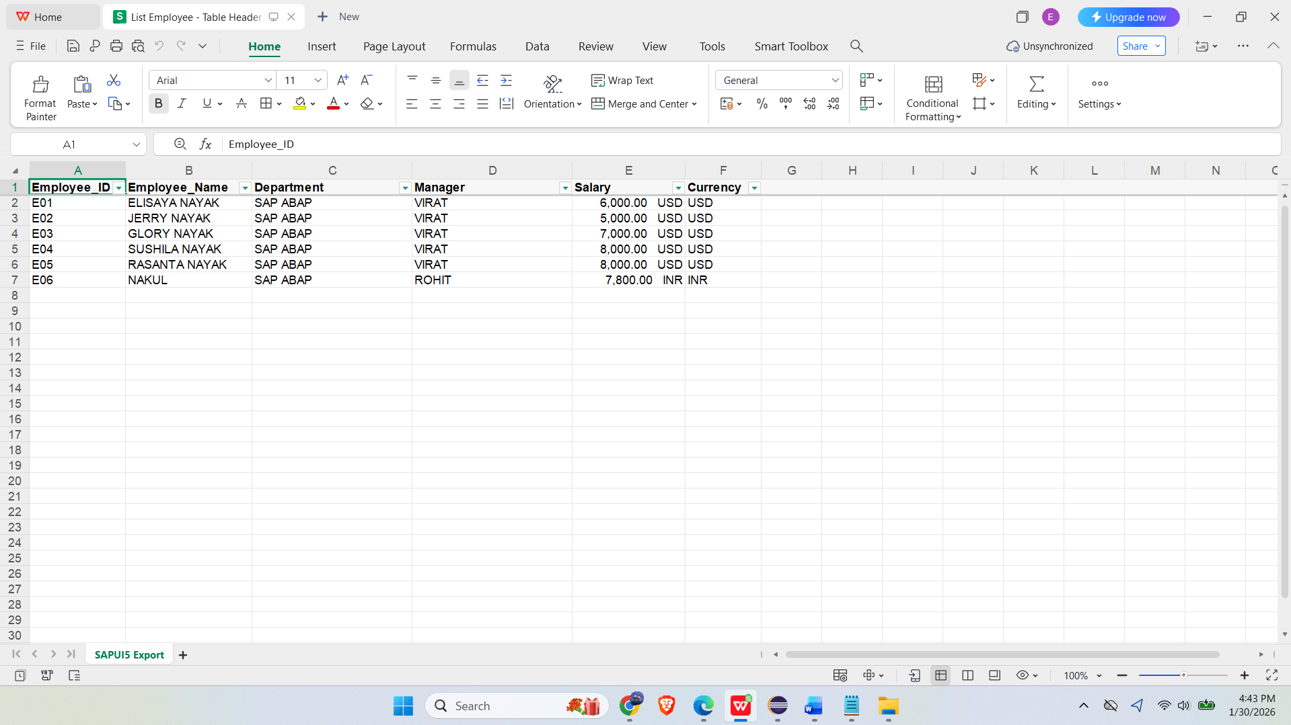

EXPORT INTO PDF
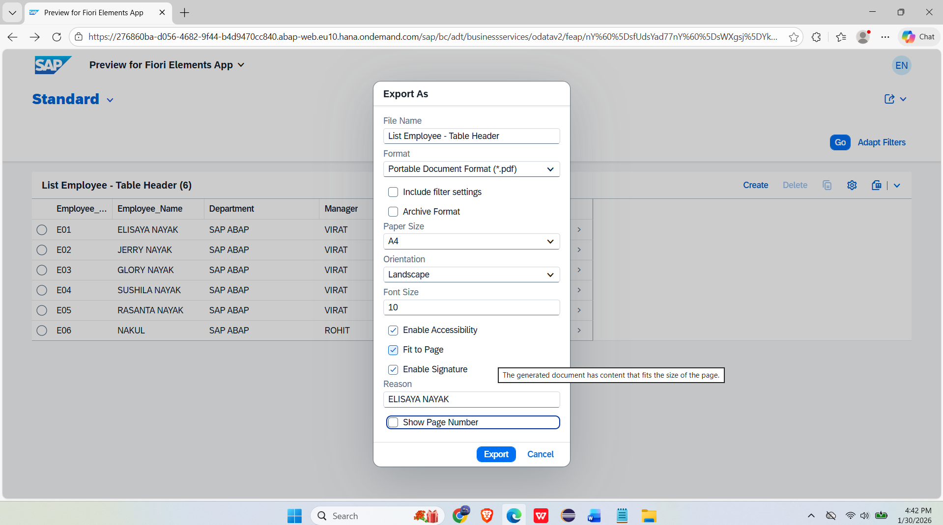

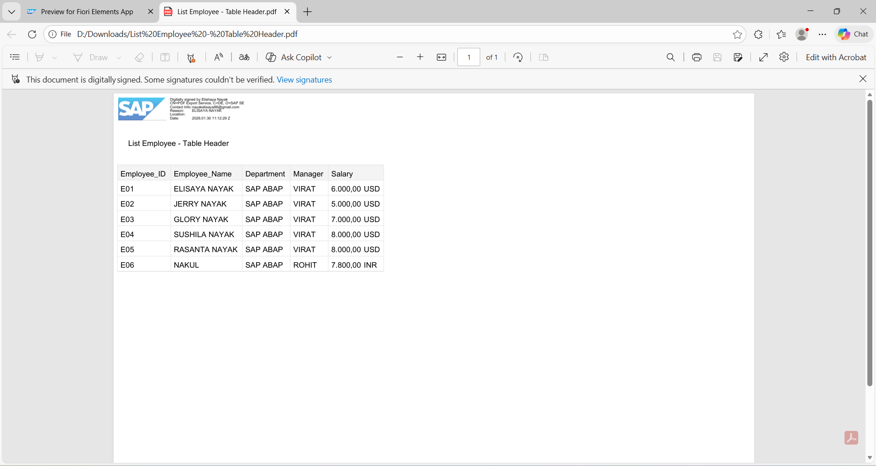

SAP ABAP FRESHER
CREATE BY ELISAYA NAYAK

